Cairo University  
Faculty of Computers and Artificial Intelligent

**CS251 - Software Engineering I**

Project Name

Software Requirements Specifications (SRS)

Geeks

Month & Year

Contents

Instructions [To be removed] 3

Team 3

Document Purpose and Audience 3

Introduction 3

Software Purpose 3

Software Scope 3

Definitions, acronyms, and abbreviations 3

Requirements 4

Functional Requirements 4

Non Functional Requirements 4

System Models 4

Use Case Model 4

Use Case Tables 5

Ownership Report 6

Policy Regarding Plagiarism: 6

# Team

|  |  |  |  |
| --- | --- | --- | --- |
| **ID** | **Name** | **Email** | **Mobile** |
| 20200651 | Youssef zayn-elabden okasha | Joozain309@gmail.com | 01118142769 |
| 20200545 | Mostafa Mohamed kamal | Mostafasheka11@gmail.com | 01024488979 |
| 20200300 | Abdallah farghal abdallah | Abdallakamal365@gmail.com | 01123936890 |
| 20200035 | Ahmed Mohamed ahmed | Ahammoudasalman@gmail.com | 01144199606 |

# Document Purpose and Audience

* The audience of this documentation is the developers who will write the implementation of the system and the purpose is to understand how the system should works in the given scenarios and the exceptions that might happen and how it should be handled.

# Introduction

## Software Purpose

The purpose of this application is top manage the parking at any garage giving it the maximum capacity and the dimension of every slot in the garage.

## Software Scope

* The ability to park in/out.
* To know the availability of the slots.
* To calculate the fees of every and each vehicle in the garage and the parking-out vehicles.

## Definitions, acronyms, and abbreviations

|  |  |
| --- | --- |
| Cash machine | a machine that takes the money and sped out the change like the Pepsi machine. |
| Best Fit Approach | Chooses the most suitable slot for the vehicle |
| First Come First Served | Chooses the first empty slot near to the gate |

# Requirements

## Functional Requirements

* park-in functionality: the customer will be able to park his car at a specific time and get the best slot for his car and if there are no free slots, the customer will be informed that the garage is full.
* Park-out functionality: the customer will be able to check-out and pay the fees of parking according to an hourly rate of 5 EGP.
* Calculate fees functionality: the system will be able to calculate the fees for each parked-out vehicle.
* Calculate total income functionality: the system will be able to calculate the total fees for the parking vehicles according to their number and staying time and display their number.
* Display functionality: the system will display all the free slots.

## Non Functional Requirements

|  |  |
| --- | --- |
|  | details |
| speed | The system shows the slot in a few seconds |
| capacity | It can work with any capacity |
| security | every car has primary information |
| usability | the system can be used 24 hours a day |
| Compatibility | It works with Cars with different sizes |

# System Models

## Use Case Model

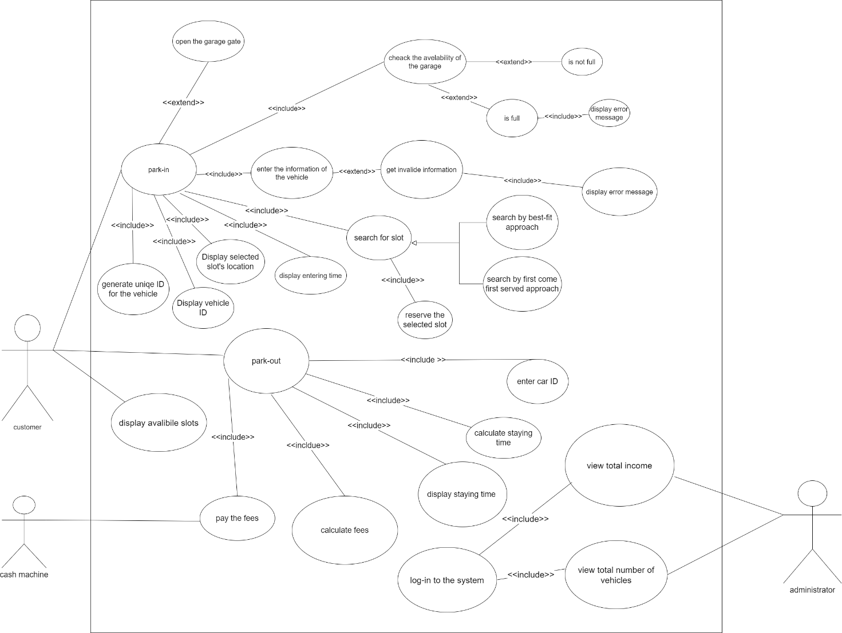

## 

## Use Case Tables

|  |  |  |
| --- | --- | --- |
| Use Case ID: | 1 | |
| Use Case Name: | Park-in | |
| Actors: | Customer , garage owner | |
| Pre-conditions: | The customer gets to the gate of the garage by his car and make a park-in request. | |
| Post-conditions: | The customer parks in the garage. | |
| Flow of events: | **User Action** | **System Action** |
| 1- the user gets by his car to the garage gate and make a park-in request by pressing the park-in button | The system checks if the garage is full or not and if the garage is not full it displays a form to the customer to enter his information |
| 2- the customer enters his car’s model name, model year, dimensions. | the system verify that the information is valid and search for the suitable slot according to the chosen config. |
| 3- the customer gets informed that his information is valid. | the system generates a unique ID for the vehicle and display the entering time, vehicle’s ID and chosen slot’s location and open the garage’s gate |
| Exceptions: | **User Action** | **System Action** |
| 1. The customer enters invalid dimensions. | The system displays an ERROR message and displays the form again. |
| Exceptions: | **User Action** | **System Action** |
|  | **2**1-the garage is full. | The system displays an ERROR message that “the parking is full”. |
| Includes: | None. | |
| Notes and Issues: | None. | |

|  |  |  |
| --- | --- | --- |
| Use Case ID: | 2 | |
| Use Case Name: | Park-out | |
| Actors: | Customer, cash machine | |
| Pre-conditions: | The customer makes a request to park out. | |
| Post-conditions: | The customer gets out of the garage. | |
| Flow of events: | **User Action** | **System Action** |
| 1- the customer makes a request to park-out by pressing park-out button | The system asks the customer to enter his vehicles ID. |
| 2- the customer enters his vehicle’s ID. | the system calculates the parking time of the vehicle and the fees of the parking and displays them. |
| 3- the customer makes the payment of the parking fees by. | The system opens the gate of the garage. |
| Exceptions: | **User Action** | **System Action** |
| None |  |
| Includes: | Park-in. | |
| Notes and Issues: | None. | |

|  |  |  |
| --- | --- | --- |
| Use Case ID: | 3 | |
| Use Case Name: | View total income and total number of vehicles. | |
| Actors: | Administrator | |
| Pre-conditions: | The administrator wants to view the total income/number of vehicles at a specific point of time. | |
| Post-conditions: | The system displays the total income/number of vehicles. | |
| Flow of events: | **User Action** | **System Action** |
| 1- the administrator logs in to the system by entering the username and the password. | The system verifies the username and the password. |
| 2- the administrator makes a request to view the total income or total number of vehicles. | The system displays the total income or the total number of vehicles. |
| Exceptions: | **User Action** | **System Action** |
| None |  |
| Includes: | None. | |
| Notes and Issues: | None. | |

# Ownership Report

|  |  |
| --- | --- |
| **Item** | **Owners** |
| Use case diagram | *Youssef zayn* |
| Use case with ID 1 | Abdallah farghl abdallah |
| Use case with ID 2 | Mostafa Mohamed kamal |
| Use case with ID 3 | Ahmed Mohamed ahmed |